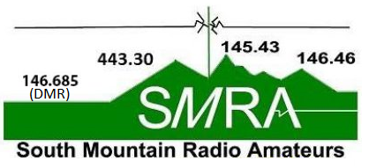 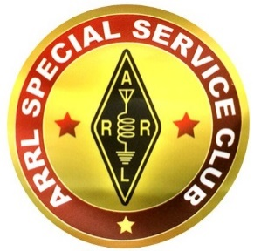c/o Michael Giordano – K3ESQ
WWW.N3TWT.ORG
221 West Main Street, Mechanicsburg, PA 17055

Thank you for your interest in becoming a member of the SMRA. We are dedicated to the local community and to amateur radio operation in the general coverage areas of the repeaters and nodes that our club operate and maintain. We also support the Cumberland County Office of Emergency Preparedness in times of emergencies, local emergency drills, and numerous other activities.

SMRA Mission Statement:
- To be a resource for advancing operational and technical skills, competency, and amateur radio licensing
- To mentor new members and enhance fellowship among radio amateurs
- To provide amateur radio communications resources and emergency communication services for the community
- To honor The Amateur’s Code

Dues: If you are a newly licensed operator (<1 yr.) no matter what class, you will receive free membership in the SMRA (the calendar year of joining plus the next calendar year). Individual Membership: $12.00/year ($10.00 via PayPal), Family Membership: $18.00/year. Dues are due before 1 March in each year. Your check is accepted in an envelope with your contact information printed on the outside.
INDIVIDUAL FAMILY | CALL SIGN(S) |  | LICENSE CLASS |  | ARRL MEMBER  YES NO
NAME(S) |  |  |  | PHONE NO. [ ] Unlisted. Do not share with members
STREET ADDRESS |  |  | CITY |  | STATE | ZIP
EMAIL ADDRESS |  |  | VE QUALIFIED?  YES NO |  | IF YES, WITH WHOM
DUES | $ | PLEASE INDICATE THOSE CLUB ACTIVITIES IN WHICH YOU PLAN TO PARTICIPATE AS A CLUB MEMBER
REPEATER DONATION | $
ATV DONATION | $ | Passing message traffic via the NATIONAL TRAFFIC SYSTEM | Repeaters and other EQUIPMENT MAINTENANCE |  | Sharing information in TECHNICAL PRESENTATIONS
ADDITIONAL CLUB DONATION | $ | EMERGENCY  Communications | Take the lead on the weekly NET |  | Assisting with  FIELD DAY
TOTAL AMOUNT | $ | BIKE RACE SUPPORT:  field communications | Digital Communications |  | Other, Please Specify
ALL APPLICANTS MUST BE VOTED ON BY GENERAL MEMBERSHIP
Steps to become a member:
- Fill out a membership application and sign the Club Waiver (Second Page)
- Get voted in at a meeting by the general membership
- Once you have a Callsign and completed the previous steps then your information will be entered into our secure club website www.n3twt.org and you will receive an email with a link to set your password.
- If you forget your password go to this link http://n3twt.org/wp-login.php?action=lostpassword Or watch the “How to log in” video http://n3twt.org/how-to

South Mountain Repeater Association, Inc. DBA South Mountain Radio Amateurs (SMRA) Disclaimer, Release and Waiver

South Mountain Repeater Association, Inc. DBA South Mountain Radio Amateurs (SMRA) is a non-profit corporation which provides equipment and volunteer personnel to perform radio communication services during training exercises and real emergencies. These services are provided to assist the various public safety agencies of several South Central Pennsylvania Counties including Sheriff, Police, Fire, etc. as well as the Federal Government (FEMA and others.) In addition, SMRA provides radio communication to various bicycle and motorcycle clubs during their annual races; conducts an annual Field Day in conjunction with the American Radio Relay League (ARRL); has monthly HAM breakfasts; monthly club meetings and sponsors or participates in other club events throughout the year.

Many SMRA activities involve hazardous situations such as emergencies of various types. They also may include carrying heavy loads of equipment; climbing and other such activities. Members should be aware of their physical limitations and may refuse any assignment for any reason.

DISCLAIMER, RELEASE AND WAIVER: I apply for membership in SMRA and elect to be a member at my own risk. I understand that SMRA activities, both in a real emergency and in training exercises, are potentially hazardous. In consideration for being allowed to participate in the SMRA’s activities, I do hereby waive, release and relinquish any and all claims against SMRA and its officers, directors and members for liability and cause(s) of action, including for personal injury, property damage or wrongful death that may result from participation in these activities. I and my heirs agree to hold harmless SMRA and its officers, directors and members from any and all claims for liability and cause(s) of action, including for personal injury, property damage or wrongful death that may result from participation in these activities.

Member Name: ________________________________________

Call Sign: ________________________________________

Member Signature: ______________________________________________

Date: ______________________
Below for use by SMRA Membership
Signed Waiver?  YES NO | Waiver Date | Voted in?  YES NO | Voted Date | Date Entered Into Roster

